On-Duty Tracking System: A Web-Based Platform for Digitizing OD Request Approval and Certificate Verification in Educational Institutions
Sharjin Jino S A, Naveen S, Ajay Ram Iyyappan
Department of Computer Science and Design
Rajalakshmi Engineering College (Anna University), Chennai, India
Roll Nos.: 241701052, 241701038, 241701004

Abstract—Manual On-Duty (OD) management in educational institutions relies on paper applications, physical approvals, and scattered records, which causes delays, misplaced documents, and poor visibility of request status. This paper presents the On-Duty Tracking System, a web-based application that digitizes the complete OD lifecycle: request submission with supporting documents, faculty and Head-of-Department (HOD) review, status tracking, email notification of decisions, and post-event certificate upload and verification. The system uses HTML5, CSS3 and JavaScript for the client, Python with Flask for the application server, and Azure SQL for persistent storage, with role-based access control separating student, faculty and HOD privileges. We describe the requirements, architecture, data flow, use cases, module design, and a functional test suite in which all eight core test cases passed. The system provides a structured, traceable and centralized alternative to paper-based OD handling and a base for planned extensions such as automated reminders, analytics, and attendance integration.
Keywords—on-duty management, workflow automation, role-based access control, certificate verification, Flask, Azure SQL, educational administration
I. INTRODUCTION
Students in higher education regularly attend workshops, seminars, symposiums, conferences, sports meets and industrial visits during regular academic hours. Attending such events requires On-Duty (OD) permission, which is traditionally obtained through paper applications, in-person approvals from faculty and the department head, and manually maintained records. As enrolment and request volume grow, this process becomes slow and error-prone: students repeatedly ask faculty for status updates, supporting documents are lost, and participation certificates are tracked in separate files or spreadsheets.
This work presents the On-Duty Tracking System, a centralized web application that lets students submit OD requests with supporting documents, lets faculty and HODs review and decide on them, notifies students by email, and supports post-event certificate upload and verification. The main contributions are: (i) a requirements analysis and role model for OD management; (ii) a workflow-driven architecture covering request, approval and certificate verification in one platform; and (iii) a modular implementation on Python/Flask and Azure SQL, with a functional test suite.
II. RELATED WORK
Web-based administrative systems in education have been widely studied. Pinho et al. [1] reviewed web portals in higher education and found that they improve communication, access to up-to-date information and decision support. Mardaniyan [2] and Falebita [3] centralized student and staff records in role-based web systems, addressing duplication, inconsistent updates and retrieval delays, and Falebita additionally emphasized protection against common web vulnerabilities. Destini and Tony [4] built a document management system with hierarchical role-based access control (HRBAC) and approval tracking, reporting a System Usability Scale score of 78.33. Adegoke and Olalekan [5] automated multi-department student clearance with role-based access, document submission, email notifications, status tracking and QR-code certificate verification.
TABLE I. Comparison of related work
Ref. | Focus | Gap relative to OD management
[1] | Higher-education web portals | General information management; no OD approval or certificate workflow
[2] | Student information system | Student records only; no request approval workflow
[3] | Secure student/staff records | Records and security focus; no OD workflow
[4] | Document administration (HRBAC) | Student-organization documents; no OD requests or certificates
[5] | Student clearance workflow | Closest workflow; targets clearance, not OD and post-event certificates
None of these systems targets the OD process specifically. The research gap addressed here is a single workflow that joins OD request submission, faculty/HOD approval, status tracking, email notification and post-event certificate verification, with role-appropriate access to each step.
III. REQUIREMENTS AND SYSTEM DESIGN
A. Requirements
Thirteen functional requirements were identified. The system must allow students to log in, maintain account details, submit OD requests with event details and supporting documents, view request status, and upload participation certificates after the event. Faculty members must be able to review, approve or reject requests; the HOD must be able to review and approve within the workflow; faculty or HOD must be able to verify uploaded certificates; and the system must send email notifications of decisions, store all records, and restrict access by role.
The non-functional requirements are performance, security (authentication and role-based access control), accessibility through a web browser, reliability, scalability, privacy of student documents, usability, maintainability and browser portability.
B. Architecture
The system follows a client–server architecture with four components: a browser-based frontend, a Flask application server, an Azure SQL database, and an email notification service. The frontend sends HTTP requests to the backend, which authenticates the user, applies role permissions, executes workflow logic, reads and writes the database, and triggers email notifications. Uploaded OD letters and certificates are linked to their corresponding OD request.
C. Roles and Use Cases
Students register or log in, submit OD requests, view request status, upload certificates and manage their profile. Faculty members view pending requests, review them, approve or reject, and verify certificates. HODs view pending requests, approve or reject, and view reports. An administrator manages users and OD types and views system reports. Fig. 1 summarizes these interactions.
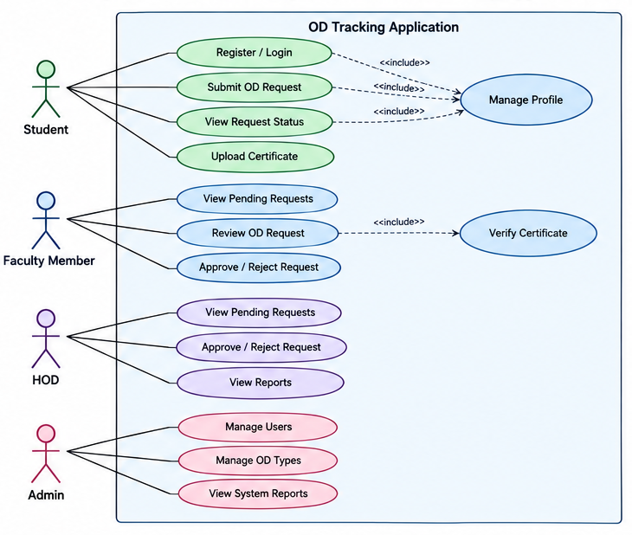
Fig. 1. Use case diagram of the OD tracking application.
D. Data Flow
At Level 0 the system is a single process: students send OD requests and documents and receive status and email updates, while faculty and HODs send approval decisions and certificate verifications. Level 1 decomposes this into four processes: (1.0) submit OD request, (2.0) review and approve request, (3.0) upload and verify certificate, and (4.0) update status and send notification, backed by three data stores for OD request, approval and certificate records. Level 2 further splits submission into entering details, uploading documents, validating and saving, and adds a faculty-to-HOD forwarding step and an email log.
E. Approval Workflow
A student logs in and submits a request with documents, which is stored and routed to faculty. The faculty member either rejects it, which updates the status and emails the student, or forwards it to the HOD. The HOD approves or rejects, and the system updates the status and notifies the student. After the event, the student uploads a certificate, which faculty or the HOD verifies, and the verification status is recorded (Fig. 2).
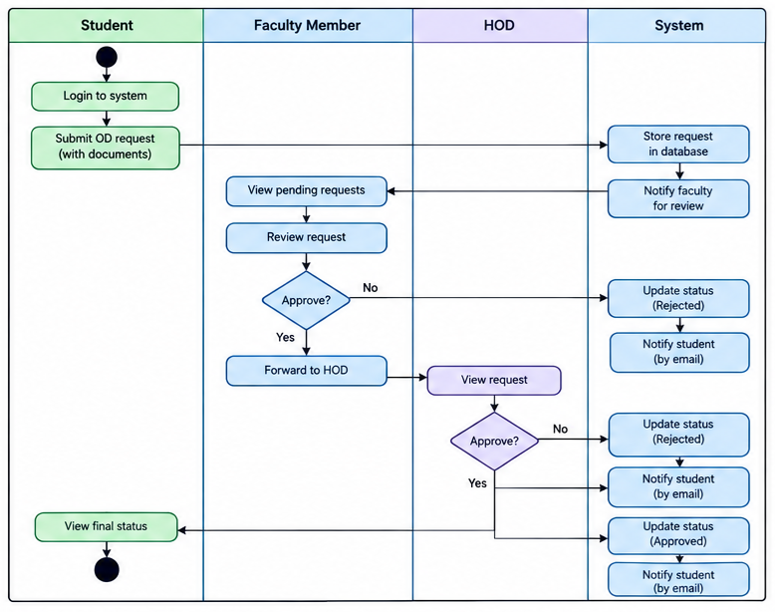
Fig. 2. Activity diagram of the OD request workflow.
IV. IMPLEMENTATION
A. Technology Stack
TABLE II. Technology stack
Component | Technology and role
Frontend | HTML5 (structure), CSS3 (layout and styling), JavaScript (interaction)
Backend | Python with Flask: routing, workflow logic, authentication, uploads
Database | Azure SQL: users, OD requests, approvals, certificates
Notification | Email integration for approval and rejection updates
Client | Standard web browser; no desktop installation
B. System Modules
The application is divided into six modules, integrated through the Flask backend and the database:
- Student Management: maintains account and student details so that each request is linked to the correct student.
- OD Request Submission and Tracking: captures event details and supporting letters, and shows the status as pending, approved or rejected.
- Faculty Approval and Review: lets faculty inspect requests and documents and approve or reject them.
- HOD Management and Approval: provides departmental review and the final decision in the configured workflow.
- Certificate Upload and Verification: stores participation proof against the OD request and records the reviewer’s verification status.
- Email Notification: sends decision and status emails triggered by workflow events.
C. Status Mapping
Each workflow stage maps a recognized input to a system action: a submitted request is recorded; a request awaiting review is shown to faculty; approval and rejection update the status to Approved or Rejected; the current status is displayed on the student dashboard; an uploaded certificate is stored with its OD request and queued for verification; and an approval or rejection decision triggers an email to the student.
D. Development Environment
Development and testing used a desktop machine with an Intel Core i5/i7 (or equivalent AMD) processor, at least 6 GB RAM and 500 GB storage, running Windows 10/11 with Python 3.10.8 and Flask.
V. TESTING AND INITIAL RESULTS
Testing covered unit testing of individual modules, integration testing of the frontend, Flask backend, Azure SQL database and email service, functional testing against the requirements, system testing of the end-to-end workflow, and white-box and black-box testing. Table III lists the core functional test cases; all passed.
TABLE III. Functional test cases
Test | Expected output | Result
User login | Valid credentials open the dashboard | Pass
OD request submission | Request with event details and OD letter is stored | Pass
Faculty review | Submitted request details displayed for review | Pass
Approval / rejection | Request status updated per faculty/HOD decision | Pass
Status tracking | Current status shown to the student | Pass
Certificate upload | Certificate stored and linked to the request | Pass
Certificate verification | Authorized reviewer can verify the certificate | Pass
Email notification | Email triggered on approval or rejection | Pass
These are initial results from functional testing; they confirm correct behavior of the implemented workflow but do not yet measure performance under load or usability with real users. Development challenges included implementing role-based access control, keeping request statuses accurate, managing uploaded documents, coordinating the faculty–HOD approval chain, and linking certificates to the correct requests.
VI. LIMITATIONS AND FUTURE WORK
The system requires internet access and a compatible browser; certificate verification is manual, so its reliability depends on the reviewer; email delivery depends on service configuration; and it is not yet integrated with attendance or student information systems. Planned work includes automated reminders for pending requests, dashboard analytics and downloadable reports, advanced certificate validation (for example QR-based verification), a mobile application, integration with attendance management so that approved ODs update attendance records, and a formal usability study and load testing.
VII. CONCLUSION
The On-Duty Tracking System provides a centralized web-based solution for OD request submission, faculty and HOD approval, status tracking, email notification and certificate verification. By replacing paper-based procedures with a role-controlled digital workflow, it reduces paperwork and manual follow-ups, improves transparency, and keeps OD records organized and retrievable. Initial functional testing passed all core cases, and the modular design allows the planned enhancements to be added without major restructuring.
REFERENCES
[1] C. Pinho, M. Franco, and L. Mendes, “Web portals as tools to support information management in higher education institutions: A systematic literature review,” Int. J. Inf. Manage., vol. 41, pp. 80–92, 2018.
[2] K. Mardaniyan, “Design and implementation of a web-based student information management system,” Int. J. Adv. Comput. Theory Eng., vol. 8, no. 1, pp. 23–27, 2019.
[3] O. S. Falebita, “Secure web-based student information management system,” arXiv:2211.00072, 2022.
[4] J. S. Destini and T. Tony, “Implementing hierarchical role-based access control for document administration in student organizations,” Internet Things Artif. Intell. J., vol. 4, no. 4, pp. 785–802, 2024, doi: 10.31763/iota.v4i4.832.
[5] T. B. Adegoke and A. A. Olalekan, “Design and development of a workflow-driven online student clearance system for seamless multi-departmental integration,” ISA J. Eng. Technol., vol. 3, no. 1, pp. 62–74, 2026, doi: 10.5281/zenodo.18506360.

